Adaptive Workflow Engine Design

Introduction
Cimarron Software Inc. (Cimarron) is a Laboratory Workflow System (LWS) and Bio Data Management company that has been contracted by SAIC and the NCI to develop a design of an Adaptive Workflow Engine. Cimarron has been designing and developing Laboratory Workflow Systems in the life sciences for over ten years. Cimarron has it own proprietary Adaptive Workflow Engine, which is currently in its third generation. Cimarron licenses the workflow engine and provides services to build custom Laboratory Workflow Systems utilizing this engine. The design put forth in this document is based on the concepts and designs of these previous and current generations of the Cimarron’s Adaptive Workflow Engine. Cimarron considers this design to be a derivative work of Cimarron’s Adaptive Workflow Engine. Cimarron grants SAIC and NCI the rights to use this design to develop an Adaptive Workflow Engine. The design below is intended to fulfill the requirements specified in the corresponding “Adaptive Workflow Use Cases” document. For additional information about the following concepts or design, please contact Cimarron directly at the following email address – info@cimsoft.com.

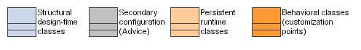
Diagram Color Key

Domain Object Model

Elements are the “real” objects in the system. They are the (usually) physical objects such as DNA Samples, Gels, and Plates, which make the journey through the Workflow.

Elements have DomainTypes which make it possible to configure programmatic rules in the system for how to handle different kinds of objects. DomainTypes are organized into hierarchies allowing for distinctions such as: “XML File” is a “File” or “human” is a “mammal”.

Elements come in several varieties: pure elements, which can model objects such as blood, data files, and individuals, and Containers, objects that can contain other objects. Containers can be further sub-divided into SimpleContainers and ComplexContainers. SimpleContainers have a single ContainerCell, while ComplexContainers have many cells, and require a Layout to be defined as part of the ComplexContainerType.

Layout is made up of LayoutCells, which have x and y coordinate positions as well as names such as “A1”.

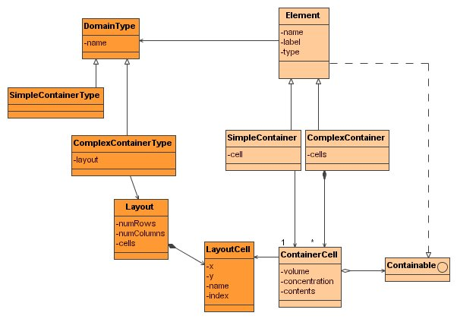

Workflow Definition

The Workflow definition forms the skeleton against which all work and data collection happens. A Workflow object is made up of WorkflowNodes, each of which is named, ordered, and owns a collection of Routes – legal destination WorkflowNodes on which items may be queued. The Workflows themselves may be collected into Applications if further grouping is desired, however the design is not dependent on this concept, and it may be deemed unnecessary.

When moving beyond definition and into Workflow Execution, a WorkflowNode may be run by “spawning” an Activity. The Activity therefore is the runtime corollary to the WorkflowNode.

Each WorkflowNode owns a collection of Activity Protocols which provide detailed options for performing operations at that Node.

A Protocol constrains the types of objects which may be input and output at that WorkflowNode, and the IOCardinalities of those inputs and outputs. For example, a given protocol may restrict inputs to a type such as 96 Well DNA Plate, and outputs to 384 Well DNA Plate, and also provide the cardinality constraint of 4-to-1, meaning that four 96 Well DNA Plates must be provided as input, while one 384 Well DNA Plate must be the output. The IOCardinality defines the minimum, maximum, and default number of Elements of a particular type that must be supplied as Input and Output.

A Protocol has versioning, active/inactive status, and an is-default property. In addition to defining the input/output aspect of the Activity, the Protocol collects together Conditions which are the data records pertinent to the Activity. Recording conditions as part of an Activity is useful for tracking values at particular point in time. A condition such as “Sample Volume” can be connected with the Protocol and given “required” status – meaning the user must supply a value, and can be given a default value, if desired.

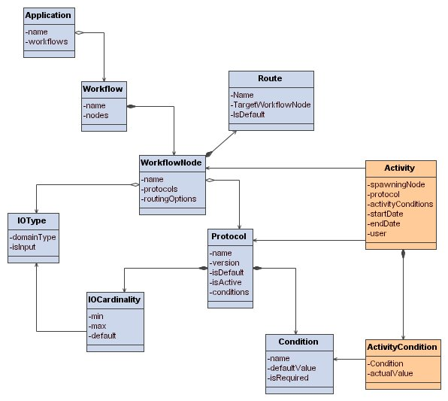

Display Workflow

Query for the Workflows which are part of the given Application. The Workflows are ordered, and each has a displayable name.

Use Case 2.1.1 Define Workflow

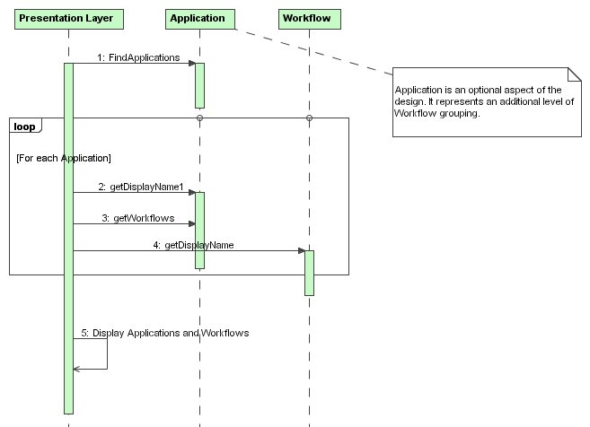

Add/Edit Workflow

Create a Workflow object with its name and displayable name; add it to its parent Application with the desired order.

Use Case 2.1.2 Add/Edit Workflow

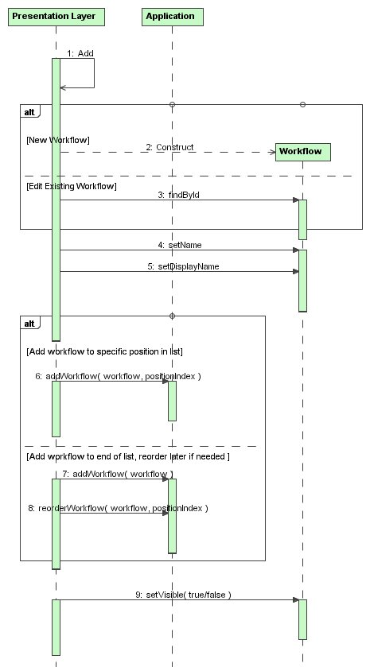

Remove Workflow

Before a Workflow can be removed it must be queried to determine whether or not it has any children dependent on it. The following pattern is proposed for dealing with this throughout the system. APIs hasChildren, delete, and deleteChildren exist on all definitional objects in the Workflow hierarchy. The caller checks hasChildren to determine whether or not the object may simply be deleted. If the object has no children, it may safely be deleted by calling delete. If it does have children, calling delete will result in a runtime exception unless deleteChildren has been called first. API call deleteChildren is a cascading call which calls deleteChildren and then delete on all child objects. This pattern, if it proves workable, may be implemented in a Deleteable interface, however, it also seems likely that the pattern will not be flexible enough and each case will be handled differently – in which case a common interface is not possible. (For example, it may be okay to delete a WorkflowNode that doesn’t have any child Protocols, but is it okay to delete that same WorkflowNode if it also has Activity records?)

Use Case 2.1.3 Remove Workflow

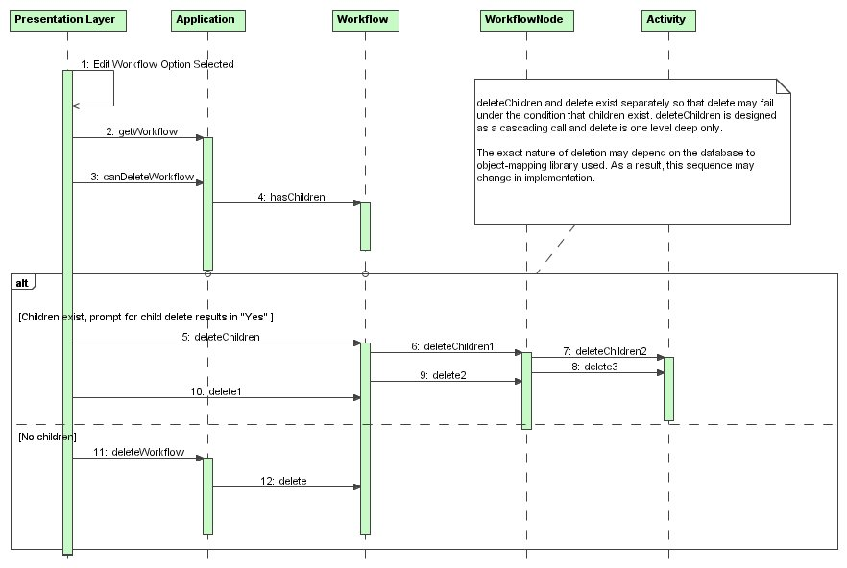

Edit WorkflowNode

WorkflowNode is made up of its name and description, as well as its order within its parent Workflow’s list. Configuration data which has to do with the customization of the software is not stored directly on as part of the WorkflowNode, but rather in an ActivityConfig object. This includes custom code plug-in points like the ActivitySaver.

Use Case 2.1.4 Add / Edit Activity Type

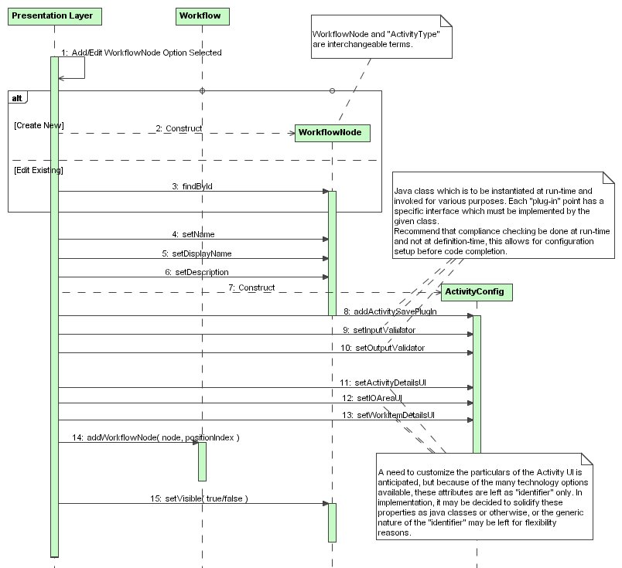

Edit DomainType

DomainTypes are simple objects with names and hierarchy. A DomainType should be able to implement an isA(DomainType) API which can determine that a Plate, for example, is a ComplexContainer, which is an Element. ContainerType is a subclass of DomainType which represents a type with a Layout. Layouts are named objects made up of LayoutCells. Layouts may not need to be configurable, but possibly may be pre-defined for objects such as 96 well plates. When defining new container types, the user should be able to choose from a selection of Layouts.

Use Case 2.1.6 Add / Edit Domain Type

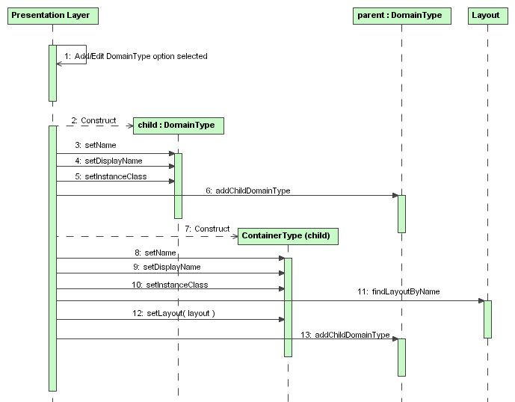

Activity Model

An Activity is the persistent representation of a user’s visit to a WorkflowNode. It stores the who, what, and when of the laboratory action.

WorkflowNodes have a queue of WorkItems – a Worklist – which is the To Do list for that node. Each WorkItem has an Element – the object on which to operate, and stores such pertinent information as Priority and QueueDate. Some WorkflowNodes may not have such a queue. These WorkflowNodes are either considered HeadWater Nodes, and they only create Outputs, or they are simply normal Nodes without Worklists which allow Inputs that aren’t on the To Do list.

When an Activity is created, the WorkItems that will be used (if any) become ActivityInputs. These input objects maintain a link to the WorkItem that created them. Non-WorkItem inputs may also be added. Later ActivityOutput objects may be added and optionally mapped to the inputs using IOMappings with reference predefined (usually) Transformation objects. Transformations are named lists of LayoutCell to LayoutCell maps.

The Activity must also be created with a specific Activity Protocol. The Protocol supplies the IOCardinality against which the Activity must be validated. Each Protocol also has the list of Conditions which must be recorded for the Activity, and each Condition has a ConditionConstraint to ensure a valid value is recorded. Specific ConditionConstraint subclass objects are supplied by the ConditionTypeFactory.

At the time that an Activity is recorded, it is the job of the ActivitySaver to actually create the Activity, add the Inputs and Outputs, and record the conditions. The Saver is a key customization point, required for handling details particular to an Activity. The Saver also is responsible for invoking any registered ActivitySavePlugins. The plug-in interface is structured such that is has pre and post API calls for each major action that the saver performs.

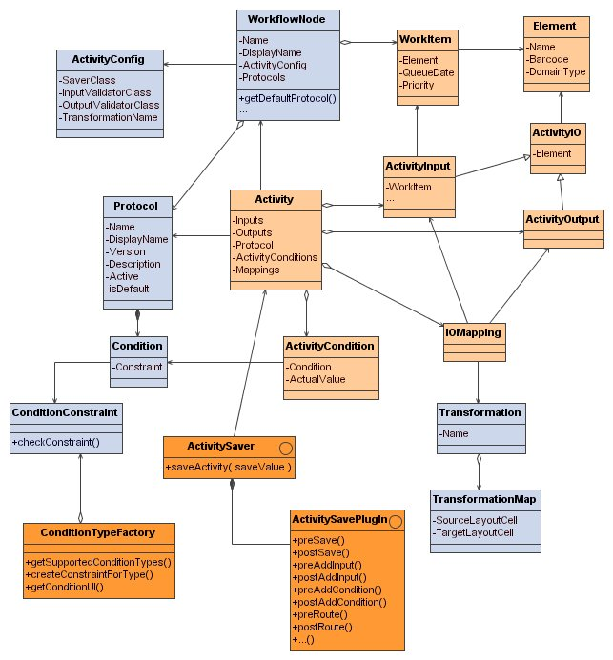

Define Activity Input/Output

WorkflowNodes have legal Input and Output types.

Use Case 2.1.8 Define Activity Input / Output

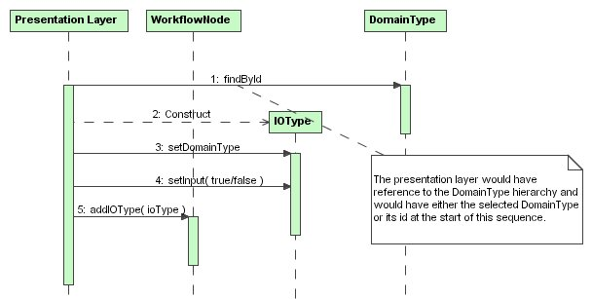

Edit Activity Protocol

Protocols strictly specify a particular way to run an Activity. The Protocol has a list of IOCardinalities which detail how many inputs and how many outputs, each of a particular type are required. Those requirements may be loose – making wide ranges with the minimum and maximum parameters, or may be tight – setting minimum to 1 and maximum to 1, for example.

Protocols are added to WorkflowNodes in a specific order.

Use Case 2.1.10 Add / Edit Activity Protocol

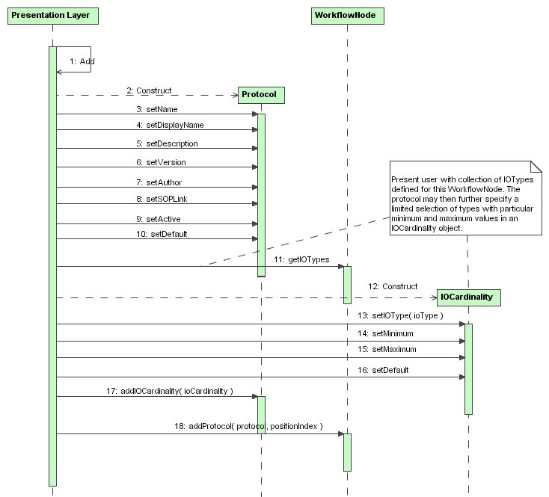

Edit Activity Condition

When adding a definitional Condition to a Protocol, the user must choose from pre-defined set of condition types. (These types do not need to be DomainTypes, Strings are adequate.) Access the list of available condition types through the ConditionTypeFactory. This factory is also responsible for creating ConditionConstraint subclass objects – one subclass per supported type.

The Condition also has attributes such as Visible, Editable, FieldUI (user-interface to use), and a ValidationClass (beyond checking the ConditionConstraint). The Condition may also be tied to a specific IOType making it “element-level”, meaning the condition value recorded at runtime will pertain to a specific input or output of the activity. Without this IOType, the condition applies to the entire Activity.

Use Case 2.1.10 Add / Edit Activity Protocol

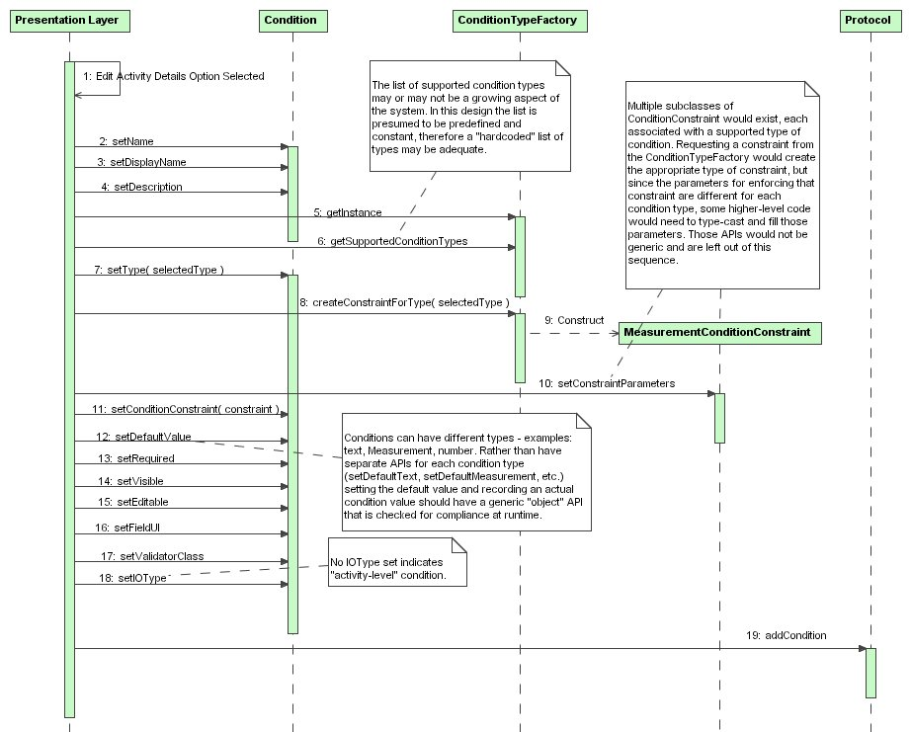

Edit Routing

To allow the user to create acceptable “routes” through the Workflow, the Route object is envisioned. WorkflowNodes would have lists of viable Routes, each of which is a union of IOType (input or output, plus DomainType), and a target WorkflowNode. A Route can be designated as the default Route for an IOType on a WorkflowNode.

Design option:
With the design as drawn, the final result looks like a chain of WorkflowNodes. It may be more desirable to have a chain of Activity Protocols instead. This can be accomplished by drilling down one step further than WorkflowNode to Protocol and performing the same operations by matching up IOCardinalities rather than IOTypes. The Routing Options would then be saved on Protocol instead of WorkflowNode.

Design option #2:
Allowable routes can be determined at runtime using the same logic as is shown in the design schematic. In this case, no Route objects would need to persist. This option may introduce more flexibility than desired and could result in the need for a list of excluded routes.

Use Case 2.1.12 Add / Edit Routing Rule

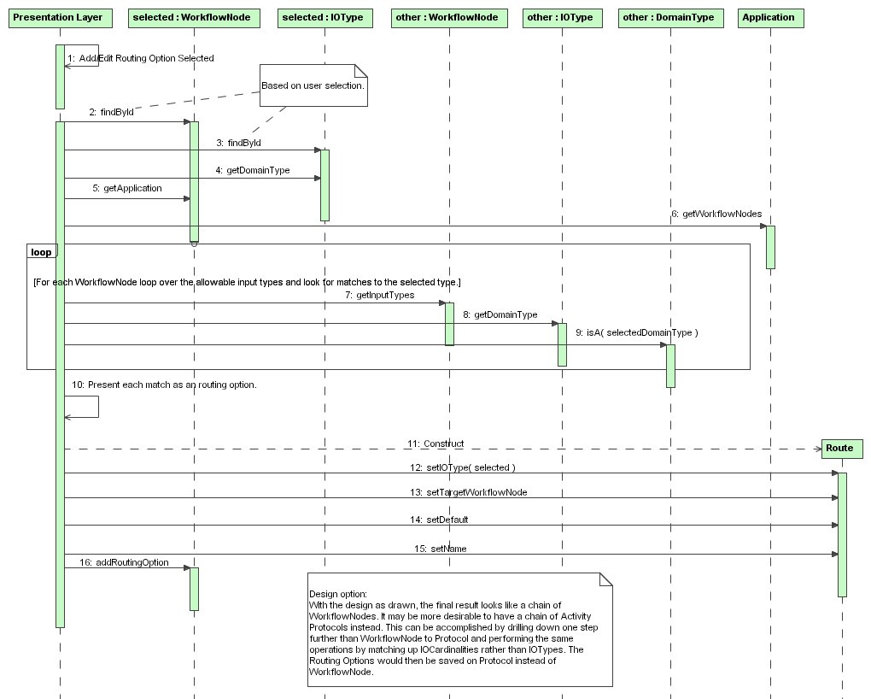

Initialize Activity

The following sequence demonstrates the relationships between the various definitional and configuration data objects, and the roles each fills in initializing an Activity Presentation Layer so it is ready to accept user input.

Use Case 2.2 Execute Workflow

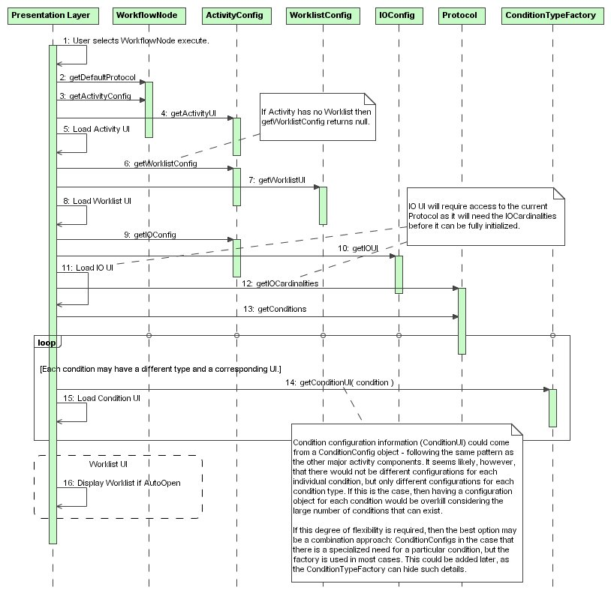

Input Output (IO) Model

The IO Model is rather abstract to accommodate the various needs of the system when input and output data is being entered in an activity. The complications arise when attempting to handle the complete range of validation necessary to keep everything in a congruent and valid state.

In effect what must happen is that when IO data is entered, the presentation layer must supply all data which is currently known to the validators. This means that when a single input barcode is supplied, the back-end InputValidator cannot accurately validate the state of the data without also knowing what other inputs, outputs, and protocol values have already been entered. It may be perfectly valid to enter a particular barcode by itself, but invalid to enter that barcode twice, for instance.

To address these needs, the concept of IOContext is introduced. When a validator is invoked, the current state of the screen data is captured and translated into an IOContext, made up of InputContexts and OutputContexts. The “context” which represents the piece of data which was just entered is marked as the “current” context. The current context is the context that is marked invalid if the entire IOContext is found to be suddenly invalid.

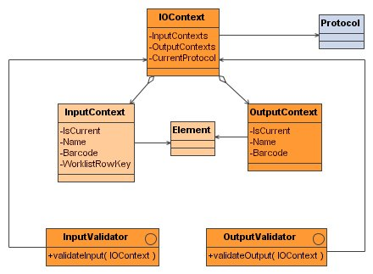

Specify Inputs/Outputs

Output validation follows the same pattern as Input validation, but does not involve the WorklistBuilder since there is no need to establish a WorklistRow link. The OutputValidator is responsible for ensuring valid Input-Output mappings, and verifying that the soon-to-be created output can legally be created (has valid unique name, etc.).

The WorklistBuilder (described more fully later on) is considered the ultimate authority on what objects are “on the Worklist”. This allows for WorkItems to remain enqueued while awaiting rendezvous with other objects, and permits more customized reasons for keeping WorkItems from the “official” Worklist.

Use Case 2.2 Specify Inputs, 2.3 Specify Outputs
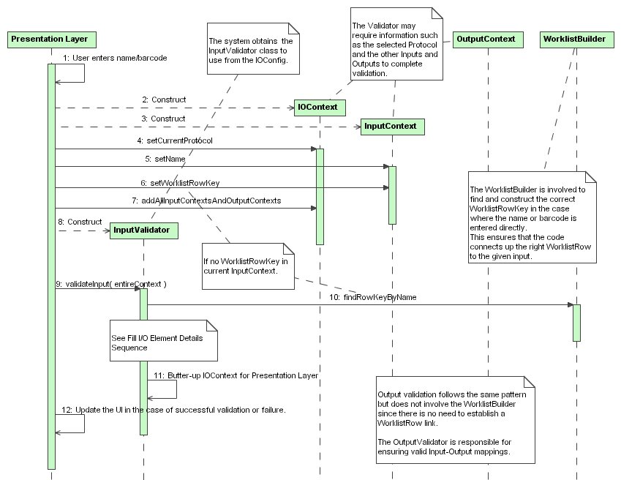

Worklist Model

The Worklist is designed for bulk querying for performance reasons. It is a report of objects awaiting work on a WorkflowNode.

The columns desired on a Worklist may not be simple properties of WorkItem or the Elements therein. The columns may show information which is only available through complex queries that cannot be generically generated. This column-centric Worklist design allows for custom WorklistQueries to be written in code and supplied to the configuration data for that column.

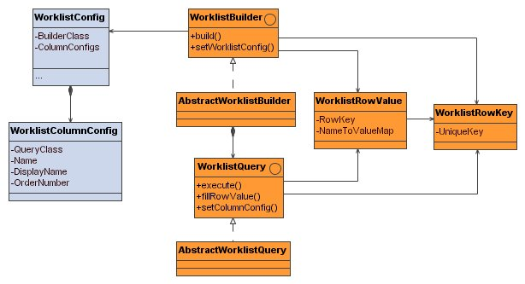

Edit Worklist

Use Case 2.1.4 Add / Edit Activity Type, AC1: Defining a Worklist

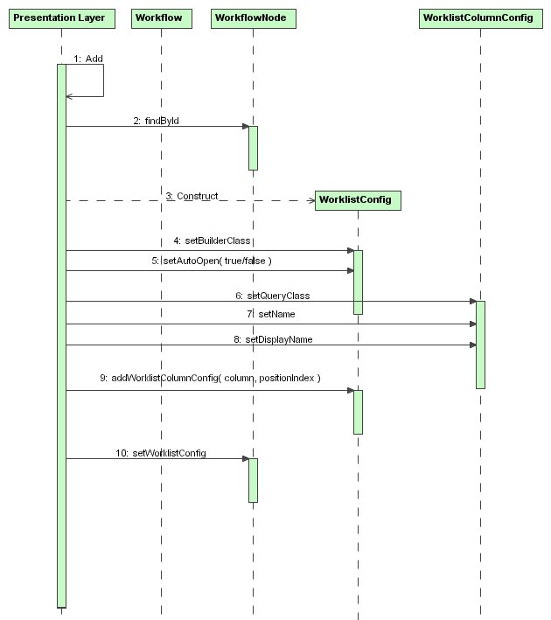

Build Worklist

When the WorklistBuilder is invoked, it references its WorklistConfig to access any additional query parameters required, and then builds a master query to find all the primary keys of the matching WorkItems. These primary keys are then abstracted into WorklistRowKeys. Then, each query class registered for a column is executed, and then asked to add its result data to a WorklistRowValue for each WorklistRowKey in the master list.

Use Case 2.2.4 Use Worklist

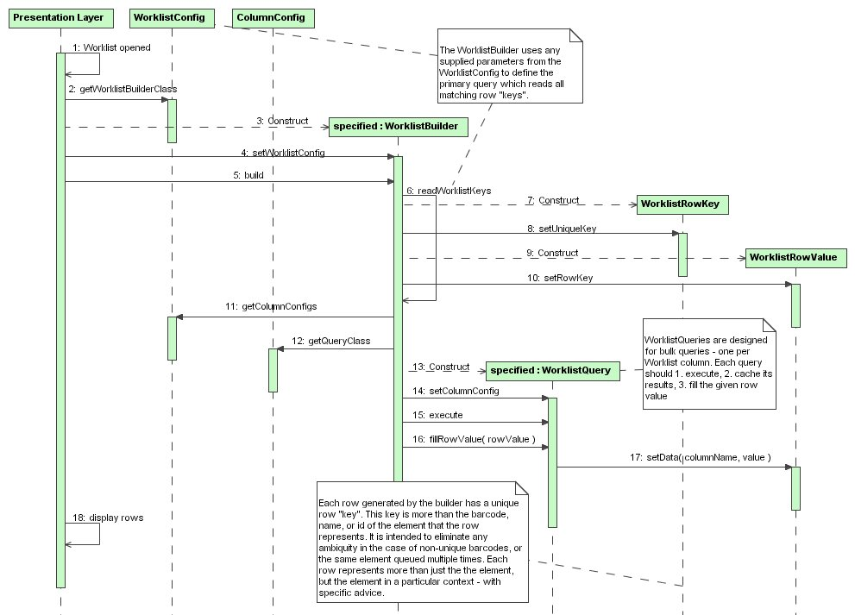

WorkRequest / Strategy / Advice Model

A WorkRequest represents the initial work that an investigator wishes to perform or have performed. The WorkRequest is made of RequestItems, each of which has a StartingWorkItem. The StartingWorkItem is the key to beginning a chain of objects which connect up to any Advice that is attached to the RequestItem via a Strategy.

Advice can be anticipated to come in three forms: ProtocolAdvice, RoutingAdvice, and ConditionAdvice. The user can plan the work to be done by preparing a chain of Advice parts, each of which can be targeted for a specific WorkflowNode and a specific IOType. A Strategy is basically a named template of Advice that can be reused.

The Strategy can define the Advice as “strict” – meaning it must be followed – or not, meaning the user would see a warning about deviating from the advice, but the system will allow the deviation. If strategies are not desired, the design can be altered to attach Advice directly to the RequestItem, and the “strict” flag can be added to either the RequestItem, or the Advice object itself.

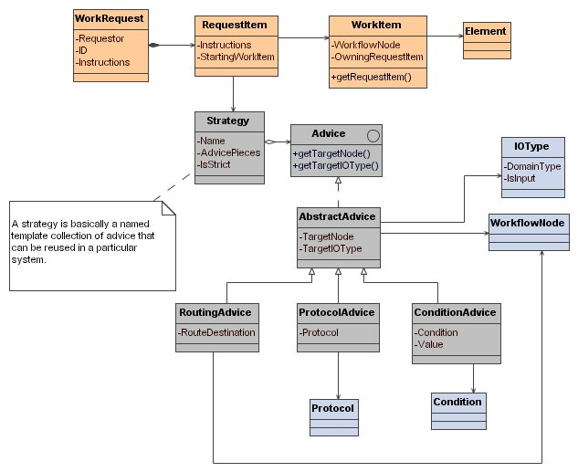

Fill I/O Element Details
When each InputValidator and OutputValidator is invoked, it queries the WorkItem on which it is operating to find its RequestItem. From there, it can match up the target WorkflowNodes and IOTypes, and ultimately determine if there is any Advice waiting for that object. That Advice could be what Protocol is supposed be used, or which “lot number” of a particular reagent must be used.

Use Case 2.2.7 Fill I/O Element Details

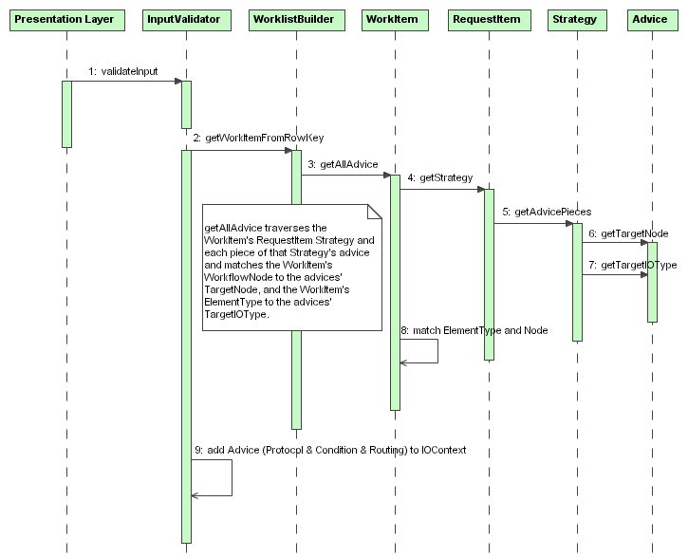

Save Activity

The ActivitySaver to use is requested from the ActivityConfig and invoked via the saveActivity API call. The saver is given an ActivitySaveValue object which contains the completed IOContext, the Protocol, each Activity Condition, and each IO object’s destined Route.

The saver is responsible for taking the following steps:
- Creating the Activity
- Setting the Protocol
- Adding all ActivityInputs (those from WorkItems and additional inputs)
- Adding all ActivityOutputs and mapping (where necessary) to inputs
- Adding all ActivityConditions
- Setting the Routing for each Input and Output
- Invoking all condition, cardinality, and IO validation
- Invoking the Router

The saver invokes each registered ActivitySavePlugin before and after each major action taken.

Use Case 2.2.1 Execute Activity Run

